Title: **A decoupled system: Spatial variation in climate, drought stress, traits and growth are largely unrelated in blue oak**

Or

**Deep roots and complex phenology decouple tree water stress from climate and growth in a xeric oak**

**Behind the curtain: The challenge of predicting drought stress in a deeply rooted tree**

**Drought exposure can’t be predicted from climate thanks to deep roots and the complex phenology of growth and trait development**

Or… Title ideas?!?

Running title:

Leander D.L. Anderegg1, Robert P. Skelton2,3, Jessica Diaz2, Prahlad Papper2, Piper Lovegreen1, Anna T. Trugman4, David D. Ackerly2,5, Todd E. Dawson2,5

1 – UC Santa Barbara, Ecology, Evolution & Marine Biology

Address: Ecology, Evolution & Marine Biology

University of California, Santa Barbara

Santa Barbara, CA 93106-9620

[landeregg@ucsb.edu](mailto:landeregg@ucsb.edu)

541.790.1096

2 – UC Berkeley, Integrative Biology, Berkeley, CA, USA

3 – South African Environmental Observation Network and School of Animal, Plant and Environmental Sciences, University of Witwatersrand, Johannesburg, South Africa

4 – UC Santa Barbara, Geography, Santa Barbara, CA, USA

5 – UC Berkeley, Environmental Science, Policy & Management, Berkeley, CA, USA

**Key Words:**

Water potential, Critical Zone, leaf area to sapwood area ratio, stable water isotopes, trait-environment relationships, trait-growth relationships

**Abstract (250 words):**

Over two decades of drought- and heat-induced forest mortality events, affecting every forested continent and both xeric and mesic forest types, have starkly highlighted the profound consequences of anthropogenic climate change for forest ecosystems and the human communities that rely on them. Yet our ability to explain the spatial patterns of these mortality events, much less predict future events, remains remarkably limited. We conducted a range-wide survey of drought stress, growth, and allocation traits that mediate drought exposure in a widespread savanna oak species (*Quercus douglasii*, blue oak) to test how predictable drought exposure is across tree populations and how water availability and allocation to leaf tissue mediate spatial variation in growth. Across 15 sites, we found surprisingly little relationship between end-of-season water availability or maximum drought stress and climate or soils data. The only strong predictor of plant water availability (within and among sites) was deep water availability inferred from stem water stable isotopes. We also found a remarkable three-way decoupling of water stress, growth, and allocation to leaf tissue from each other. Collectively, our results reveal that the seasonality of growth, trait development and the water stress that determines mortality risk are phenologically disconnected in Mediterranean-type climates and that complex below ground structure can hydrologically decouple tree water stress from above-ground climate. We contend that a poor understanding of carbon gain and mortality risk in seasonal environments and limited data on critical zone hydrology make it hard to predict the spatial pattern and physiological consequences of drought stress in deeply rooted trees.

**Introduction: (Current word count 6400)**

As humans load the dice of the climate system towards more frequent and severe droughts, the potential for catastrophic ecological consequences such as regions-scale forest mortality events becomes increasingly evident (Allen *et al.* 2010; Brodribb *et al.* 2020; Hammond *et al.* 2022). Two decades of intense ecophysiological research to understand how climate change-type droughts drive forests over the brink has revealed that direct cavitation and eventual failure of the hydraulic system interacts with disruptions to carbon metabolism - particularly for defense against biotic agents - to drive tree mortality during drought (Adams *et al.* 2017; Brodribb *et al.* 2020). This insight has driven a focus on plant hydraulics as they key to understanding and predicting spatial patterns of forest mortality (Tai *et al.* 2016). However, to date our ability to hindcast which trees will die where remains extremely limited (Anderegg *et al.* 2016; Benito Garzón *et al.* 2018; Trugman *et al.* 2021; Venturas *et al.* 2020).

The inability for physiology alone to predict the spatial distribution of drought mortality events highlights two issues. First, within-species variation, driven either by ecotypic/genetic differences among populations or plastic/acclamatory trait responses to environmental cues, complicates our spatial understanding of vulnerability to drought-induced damage (Laforest-Lapointe *et al.* 2014; Rosas *et al.* 2019; Trugman *et al.* 2021). In particular, allocation to evaporative leaf area versus conductive stem area (Al:As ratio) has emerged as a key physiological knob that trees can turn to balance hydraulic demand (Al) with hydraulic supply (As) (Mencuccini *et al.* 2019b; Mencuccini & Grace 1995; Sanchez Martinez *et al.* 2020; Trugman *et al.* 2019). Decreasing leaf area per unit stem area helps plants avoid extremely negative xylem water potentials during drought by increasing leaf area-specific hydraulic efficiency (Martinez-Vilalta *et al.* 2009). Because extremely negative xylem water potentials are the cause of xylem cavitation, by mediating plant hydraulic efficiency Al:As is a key regulator of drought exposure (the amount of physiological stress a plant experiences during water deficit)(Whitehead & Jarvis 1981). While many within-species trait-climate relationships have proven esoteric and context dependent (Anderegg 2023), variation in Al:As within an individual species in response to water limitation has emerged as a consistent pattern across studies and systems (Anderegg & HilleRisLambers 2016; Anderegg *et al.* 2021; Martinez-Vilalta *et al.* 2009; Mencuccini & Bonosi 2001; Rosas *et al.* 2019). Moreover, a relatively large proportion of global variation in allocation traits occurs within species, in contrast with most other traits that vary primarily at large evolutionary scales and show substantial phylogenetic signal (Anderegg *et al.* 2022; Sanchez Martinez *et al.* 2020). Thus, variable allocation to leaf area may be a key acclamatory mechanism driving within-species variation in hydraulic architecture (Anderegg *et al.* 2023), which has profound consequences at both the organismal and ecosystem level (Mencuccini *et al.* 2019a; Quetin *et al.* 2023). From a carbon economy perspective, biomass-based traits such as the mass of leaves relative to the mass of stems (Ml:Ms) are an alternative basis for quantifying leaf:stem allocation, and also show relationships with water availability (Ledo *et al.* 2018; Poorter *et al.* 2012), though they have been less studied from a water stress perspective than Al:As.

The second major complication for predicting spatial patterns of mortality is our poor understanding of drought exposure on the landscape. Even as our gridded climate products improve and multiply, our understanding of tree-level critical zone hydrology (from the top of unweathered bedrock to the soil surface) remains quite limited (Callahan *et al.* 2022; Dawson *et al.* 2020; Fan *et al.* 2019; Hahm *et al.* 2022; Rempe & Dietrich 2018). As a consequence, translating meteorological drought into ecological drought based on our understanding of plant available water remains quite challenging (Anderegg *et al.* 2013), particularly in geologically and topographically complex landscapes. Water balance metrics that integrate water supply and demand are the go-to climate or meteorological variables for understanding ecologically relevant drought or spatial variation in water stress (Berner *et al.* 2017; Ledo *et al.* 2018; Mitchell *et al.* 2016; Stephenson 1998, 1990). These range from simple ‘moisture deficit’ calculations (MD, precipitation minus potential evapotranspiration) to modeled ‘climatic water deficit’ (CWD, potential evapotranspiration minus modeled actual evapotranspiration) that estimate the mismatch between water availability and water demand. However, all of these approaches require substantial assumptions about what the hydrologically relevant water bucket is. For CWD calculations, this involves using a simplified soil hydrological model, usually based on large-scale gridded soils data of 1-3m depth, and a model of actual evapotranspiration constrained by this soil bucket (Abatzoglou *et al.* 2018; Flint *et al.* 2013). However, not only are our soils data typically not deep enough to represent deeply rooted tree species, they are often quite coarse and inaccurate outside of heavily sampled agricultural areas (cite). Plus, rock water beyond the classic ‘soil’ water has proven a major water source for many forests globally (McCormick *et al.* 2021). Thus, most of our tools for understanding climatic or meteorological water limitation drastically simplify the otherwise highly complex Critical Zone hydrology that actually controls tree exposure to drought stress. It remains an open question whether we can accurately describe drought exposure across the landscape, given these data limitations.

The blue oak tree (*Quercus douglasii* Hook & Arn.), is an ecologically and culturally important foundation species that dominates low elevation woodlands and savannas across California, U.S.A. This deciduous tree species is valued for dendroclimate reconstructions because of its high growth sensitivity to precipitation (Stahle *et al.* 2013), and is thus an ideal focal species for studying drought stress as water limitation appears to be a key limit to performance across much of its range. Blue oak also experienced substantial mortality, particularly across southern portions of its geographic range, during the California 2012-2016 drought (Das *et al.* 2019), though only about 30% of the spatial variation in mortality patterns across its range could be explained by climate, drought severity, or groundwater depletion (Brown *et al.* 2018). Spatial variation among populations in hydraulic thresholds to damage (leaf and stem P50, or the xylem water potential that causes 50% embolism) appears limited in blue oaks (Skelton *et al.* 2019), which suggests that understanding spatial variation in drought exposure (either due to trait shifts such as decreasing Al:As that avoid drought stress or due to complex hydrological water limitation) is likely key to predicting blue oak mortality (McLaughlin *et al.* 2020).

We measured end of dry season soil moisture availability, maximum midday water stress (collectively ‘drought exposure’), stable water isotope tracers, leaf and allocation traits, and growth rates across the geographic range of a xerophytic oak tree and asked 1) can we explain the spatial variation in drought exposure across the landscape using climate, soil and isotopic information? 2) how do leaf and allocation traits, particularly Al:As vary as a function of climate or drought exposure? 3) do individual tree growth rates correspond to site climate, observed drought exposure, or variation in traits? Finally, we used a mechanistic tree hydraulics model to integrate our observations of drought exposure, traits, and growth to test whether observed traits are hydraulically optimal and whether a synthetic model integrating traits and climate can explain growth better than empirical, univariate relationships.

We predicted drought exposure would be broadly correlated with climatic water balance, but that climate would explain more variation in water availability than maximum water stress due to stomatal closure at the driest sites. We also hypothesized that observed drought exposure would be a better predictor of both allocation traits and growth than climate or soils data, with water availability explaining allocation traits and midday water stress and the soil-leaf water potential gradient explaining growth variation. Finally, we hypothesized that a mechanistic plant hydraulics model would facilitate the integration of drought exposure and allocation traits to explain growth variation based on modeled carbon gain.

**Methods:**

*Study System*

We measured spatial variation in plant water stress, leaf traits, and growth across the geographic distribution of blue oak (*Quercus douglasii* Hook & Arn.), a deciduous tree species endemic to California, USA around the California Central Valley (Fig. 1a). Blue oak inhabits sites experiencing a wide range of precipitation and potential evapotranspiration (Fig. 1b). Blue oak experiences a Mediterranean-type climate, with a hot, dry growing season from roughly April to September and the vast majority of precipitation falling during the cool winter usually December to March .

We selected 15 study sites that span the majority of the precipitation and potential evapotranspiration range inhabited by blue oak. At the end of the 2018 growing season from 17-27 Sept, when trees were experiencing the annual minimum soil moisture but before leaves had begun to senesce, we sampled predawn and midday leaf water potentials, collected terminal branches for trait measurements, measure leaf gas exchange, and collected tree cores for water stable isotope analysis and growth analysis. We prioritized visiting all sites in as short of a time period as possible to maximize the comparability of water potential measurements, at the cost of some ancillary measurements at some sites. We measured predawn and midday water potentials at all 15 sites, but due to logistical constraints only measured traits at 12 sites, growth and isotopes at 11 sites, and leaf gas exchange on a small subset of trees at 7 sites.

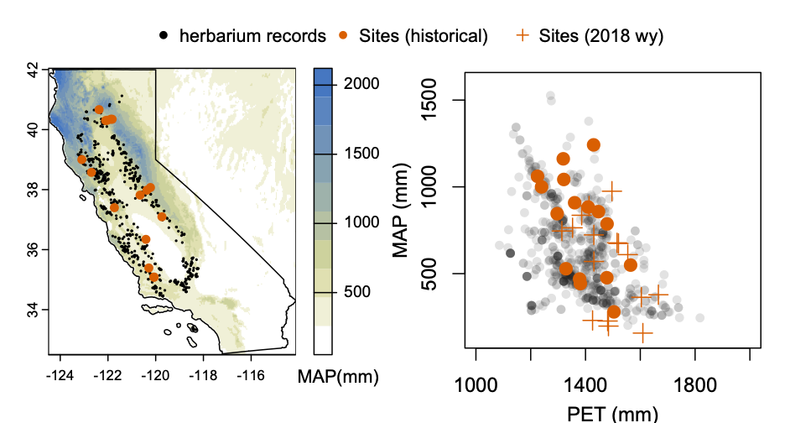

**Figure 1:** *a) The geographic distribution of blue oak (Quercus douglasii) in California, USA spans a large range of mean annual precipitation (MAP in mm, from TerraClimate (Abatzoglou et al. 2018)). Black points show locations of herbarium specimens (Baldwin et al. 2017), sampled locations are shown as orange points. b) Sampled locations span the vast majority of the mean annual precipitation and potential evapotranspiration (PET) space inhabited by blue oak. The 2018 water year (crosses) when samples were collected was substantially hotter and drier than the 1981-2010 historical period (filled points).*

*Leaf water potential*

We quantified soil moisture availability by measuring predawn leaf water potential (ΨPD) between 3am and first light (local time). Assuming limited nighttime transpiration and full equilibration of the tree with the soil, ΨPD reflects the root zone-integrated soil matric potential. We measured water potential on 3-8 leaves from each of 5-7 trees per site (mean 5.5), either severing the petiole with a sharp razor blade directly from the tree (for short trees) or collecting a branch >50cm long using pole pruners and then immediately cutting 2-3 leaves using a razor blade. Leaves were immediately wrapped in tinfoil and a lightly damp paper towel (to limit evaporation without rehydrating the leaf) and measured in a Scholander-type pressure chamber (PMS Instruments, Corvallis, OR, USA) within 1 min of cutting. A ‘modified petiole’ that retained >50% of the leaf lamina (Rodriguez-Dominguez *et al.* 2022) was quickly cut using a razor blade for leaves that did not extend beyond the pressure chamber lid.

We then measured minimum leaf water potential at midday (ΨMD) between 12:30 and 2pm local time to estimate maximum water stress. Given that the sampling year of 2018 was drier and hotter than average (Fig. 1b), these end-of-season ΨMD measurements are likely reasonable estimates of longer term Ψmin values for these trees (minimum leaf water potential experienced by the tree), though the minimum water potentials observed in trees near two of the sampling sites in the midst of the extreme 2012-2026 California drought were ~0.5 MPa more negative than the values we observed at those sites (Weitz 2018). Midday water potentials were measured similarly to predawn measurements, except time between leaf cutting and sample measurement was minimized to <30s. For a subset of 2-4 trees at 6 sites, we also measured branch xylem midday water potential by wrapping leaves in tinfoil and bagging terminal branches in a plastic back with damp paper towels to stop transpiration for at least 20 mins prior to leaf collection. Xylem water potential was on average 8% less negative than leaf water potential. Finally, we calculated ΔΨ (the transpirative water potential drop or water potential gradient driven by transpiration) as ΨPD - ΨMD.

*Trait measurements*

At 12 of the 15 sample sites, we collected leaf and stem tissue for trait measurement. Using pole pruners, we collected 3 terminal twigs from 5 trees measured for water potential, from the south facing, sun exposed mid- to upper-canopy. Terminal twigs included the current year (2018) stem growth, identified by previous year bud scar, and all subtending leaves. Thus, they represent one year’s investment in branch and leaf tissue. Branches were rehydrated using the ‘partial rehydration’ method (Pérez-Harguindeguy *et al.* 2013) and stored in a cooler or refrigerator for at least 12 hours before sample processing. In the lab, all leaves attached to each terminal twig were removed, weighed for their wet mass (Ml_wet), and scanned on a flatbed scanner. Images were analyzed with ImageJ (Schneider *et al.* 2012) to calculate whole twig leaf area (Al), and total leaf area was divided by leaf number to estimate average leaf size. Stem basal diameter underneath the bark was measured at 2-5 radii using digital calipers and average diameter was used to calculate stem cross sectional area (As). Total twig Al was divided by stem As to calculate branch Al:As ratio. Stem length was also measured with calipers or a ruler. Leaves and stems were then oven dried at 60°C for 72 hours, and their dry mass measured (Ml, Ms). Leaf mass per area (LMA) was calculated as Ml / Al. We calculated leaf mass to stem mass ratio (Ml:Ms) by dividing leaf dry mass by stem dry mass, and leaf dry matter content (LDMC) was calculated by dividing leaf dry mass by leaf wet mass (Ml/Ml_wet). Because samples were not processed in the lab until after the 10 day water potential campaign, some samples were stored for >2 weeks before processing. While leaf area and dry mass were unlikely to be influenced by this storage, we excluded LDMC values from samples that were stored longer than 1.5 weeks from analysis, resulting in exclusion of LDMC values from four sites.

*Stable water isotopes*

Xylem water 18O and deuterium (2H or D) content was measured at 11 of the study sites on 5 trees (7 trees at two sites, 3 trees at one site). Tree cores of roughly 4cm length were extracted from study trees at breast height, rapidly placed in pop top scintillation vials (after removing bark and cambium), wrapped in parafilm and stored in a cooler until frozen in the lab. Water was cryogenically extracted (Ehleringer *et al.* 2000). The amount of 18O in extracted samples was determined through mass spectrometry by CO2 headspace equilibration using a Gas Bench II (GB, ThermoFinnigan) connected to a Delta Plus XL mass spectrometer (ThermoFinnigan, Bremen, Germany) at the Center for Stable Isotope Biogeochemistry (CSIB), University of California, Berkeley, CA. The deuterium content of samples was determined via injection into a H/Device (HDEV, ThermoFinnigan, 30 Bremen, Germany) coupled to a Delta Plus mass spectrometer (ThermoFinnigan), also at CSIB. All isotopic compositions are reported in delta (d) notation in parts per thousand (‰) relative to the V-SMOW standard

$δ18O or δD=\left(\frac{R_{sample}}{R_{standard}}-1\right)*1000$ (eq 1)

where R = 18O/16O or D/H.

Estimates of monthly meteoric water isotope values were estimated for each site using the Online Isotopes in Precipitation Calculator, version OIPC3.2 (Bowen *et al.* 2005; Welker 2000). As one estimate of the amount of evaporative enrichment, the deuterium enrichment of each sample relative local meteoric water line calculated from these precipitation estimates was used to calculate ‘line conditioned’ D excess (lc-excess, (Landwher & Coplen 2004)). Average meteoric water isotopic values for the sampling year (δDprecip, δ18Oprecip) were calculated for each site by precipitation-weighting the monthly δD and δ18O, multiplying each month’s isotopic values by the 2017-2018 water year precipitation from that month, summing the all months, and dividing by the total water year precipitation.

*Growth*

Growth was estimated using three methods. First, we measured the branch length of terminal branches collected for trait measurements (12 sites) as a metric of 2018 branch growth. Second, we saved the tree cores collected for water isotopes after cryogenic extraction, sanded them and measured the most recent five years of ring widths using calipers and a dissecting scope as an estimate of recent stem growth. We translated radial growth into basal area increment (BAI) based on tree DBH. We then corrected for size-related BAI trends by calculating each tree’s growth relative to the maximum observed growth at that DBH across all sites. We fitted a quantile regression to the 90th percentile BAI~DBH relationship, and then calculated each tree’s size-standardized growth as the ‘percent of maximum BAI’ (% max BAI) or the observed BAI divided by the 90th quantile BAI for the tree’s DBH.

*Climate and meteorological data*

Both long term climate normals (1981-2010) and meteorological data from the 2017-2018 water year (the year of sample collection) were extracted for each site from TerraClimate (Abatzoglou *et al.* 2018). TerraClimate has ~4km resolution monthly climate and climatic water balance values for the global terrestrial surface from 1958 to 2020 (updated periodically). As potential historical climate predictors (1981-2010) of plant water potential, traits, and growth, we extracted site mean annual precipitation (MAP); potential evapotranspiration (PET, based on the Penman Montieth approach); actual evapotranspiration (AET using the Thornthwaite-Mather climatic water balance method with a single bucket model on a monthly timestep using 0.5° extractable soil water storage capacity data from (Wang-Erlandsson *et al.* 2016)); climatic water deficit (CWD = PET – AET); mean annual soil moisture (Soilmean from bucket model); incident shortwave radiation (SWR); maximum temperature of the warmest month (Tmax); minimum temperature of the coolest month (Tmin); maximum annual, spring average and growing season average vapor pressure deficit (VPDmax, VPDspr). We also included potential predictors from the 2017-2018 water year (termed ‘water year meteorology’ throughout), including PPT, PET, AET, CWD, Tmin, Tmax and Soilmean from the entire water year (2018 wy [variable]); plus seasonal variable including growing season PPT, VPD, and Soilmin; dormant season PET; and spring Tmax and Tmin. These variables were selected by balancing a priori expectations for the climatic variables that should influence growth and water stress with the inclusion of a few seasonal variables that were found to be not highly correlated with annual variables. Many of these variables were still highly colinear. However, to avoid model overfitting and collinearity issues, we only ever fit one climate/meteorological predictor in any model, and we chose not to over-interpret the inclusion of specific variables over others in the best-fit models.

*Soils data*

We extracted plant available water (PAW), available water storage (AWC), and minimum bedrock depth for each site from the Soil Survey Geographic Database (SSURGO) database. The data was collected at scales ranging from 1:20,000 to 1:24,000. Both AWC (0-100cm) and minimum bedrock depth were taken from the soil map unit composition. In two sites where minimum bedrock depth was not available we extracted the data from the dominant soil series. PAW (cm) was pulled from the dominant soil series in the soil map unit.

*Leaf gas exchange*

For a small subset of trees (1-4 trees at 7 sites, 16 total trees), we estimated stomatal conductance (gs) and photosynthesis (As) as a function of leaf water potential at midday. Using a LI-6800 gas exchange system (LI-COR Biosciences, Lincoln, NE, USA), we collected spot measurements of gs and As by setting the chamber to ambient temperature and relative humidity and light to 1500 μmol m-2 s-1. Measurements were made after the conditions in the chamber stabilized (~1min) but before stomata began to react to the chamber environment (typically 3-5 mins). For small leaves that did not fill the chamber, leaf area in the chamber was marked with a sharpie and later scanned to correct for leaf area. Following gas exchange measurements, water potential was measured on a leaf immediately adjacent to the measured leaf. At one site, repeated gas exchange and water potential measurements were conducted from 7 a.m. to 12:00 p.m. on one tree. At another site

*Mechanistic model simulations*

We used the HOTTER model (the ﻿**H**ydraulic **O**ptimization **T**heory for **T**ree and **E**cosystem **R**esilience model (Quetin et al 2023), a physiologically-based tree model with a realistic representation of gas exchange (B. Eller et al., 2018) and a detailed representation of plant hydraulics (Trugman et al., 2018) to quantify spatial variations in tree water status, hydraulic stress, and carbon gain across gradients in climate and plant traits in the continental United States (US). A detailed model description can be found in Quetin et al (2023)

HOTTER model forcings include atmospheric CO2 concentrations, temperature, vapor pressure deficit, and soil water potential. In addition, the tree model requires inputs or allometric equations for the state of the tree, leaf area, and tree size. The hydraulic and photosynthetic dynamics of the model are primarily controlled by three plant physiological traits: the water potential and 50% loss of conductivity (P50), the conductivity of the roots, xylem, and petioles (Kmax), and the maximum rate of carboxylation (Vc,max), a trait which is sensitivity to temperature. HOTTER diagnostic outputs include tree-level transpiration, gross and net carbon assimilation, canopy conductance, water potentials, and percent loss of conductivity (PLC) for all of the tree’s conductive elements: roots, xylem, and leaves. Model outputs are daily-level and assume 12 hours of daylight for carbon assimilation during the growing season and 24 hours of respiration.

We used blue oak species mean observed hydraulic traits from (Anderegg *et al.* 2023; Skelton *et al.* 2019) (Vcmax25 = 20 umol m-2 s-1; P50 = -4.3 MPa). Kmax was estimated from early growing season Knative values (Kmax = 7600 mmol m-2 s-1 MPa-1). Leaf area was parameterized scaling mean branch Al:As to the tree level. Soil water potential for forcing HOTTER was derived tree-specific predawn water potentials taken during the sampling campaign in September, 2018. Temperature and VPD were derived from dynamically downscaled historical climate data to 1-hourly, 1.5-km spatial resolution using the Weather Research and Forecasting Model (WRF). Climate data was aggregated to the daily level for forcing HOTTER where we took the 80th percentile temperature and corresponding pressure and specific humidity as representative of the average conditions during which plants photosynthesizing during daylight hours and used the Clausius Clapeyron equation to calculate the corresponding VPD for the period of Sept 17-27, the same dates as the water potential sampling campaign. This spans a wide range of climate conditions experienced by these blue oak population both across space and over time in September, as a heatwave drove an approximate doubling of VPDs between the beginning and end of the sampling period for all sites.

To estimate variability in plant physiological diagnostics during the sampling period, we performed separate experiments on the median, most, and least stressful day during the sampling period (as defined by VPD). We ran separate simulations for each tree with tree specific leaf area and soil water access, site-specific climate, and species-specific hydraulic and photosynthetic traits. Additionally, the examine the uncertainty in how leaf allocation influences carbon and water dynamics, we performed a separate set of experiments where we reduced tree leaf area by half.

*Analysis*

We averaged all attributes to the tree level for analysis (87 total trees, fewer for traits, water isotopes and growth). We then sought to explain spatial variation in plant water potentials (ΨPD, ΨMD, ΔΨ), plant traits (Al:As, Ml:Ms, leaf size, LMA, LDMC), xylem stable water isotope composition (δ18O, δD, and lc-excess), and growth (branch length, tree height, % max BAI) using information-theoretical based model selection, in the R statistical environment (version 4.3.1, (Team 2016)). We fit linear mixed effects models relating each response variables to each of the 20 climate or meteorological predictors (described above) individually with a random intercept for site, using the lmer() function in the ‘lme4’ package (Bates *et al.* 2015). We then used AICc (Akaike’s Information Criterion corrected for small sample sizes) to select the most parsimonious model of the 21 possible models (20 climate predictors plus a null model). Predictors were considered significant if they improved model AICc by 2 or more units over the null model (intercept only). We used t-tests based on Satterthwaite's approximate degrees of freedom to determine the p-value of significant climate predictor, using the ‘lmerTest’ R package (Kuznetsova *et al.* 2016).

We also used linear mixed effects models with a site random intercept term to test whether xylem water stable isotopes explained tree-to-tree variation in plant water potentials, again using t-tests and Satterthwaite's approximate degrees of freedom to quantify statistical significance.

**Results:**

*Predicting drought stress*

Despite sampling across large geographic differences in both precipitation and potential evapotranspiration (Fig. 1), and despite massive differences between sites in leaf water potential (-0.82 MPa to -3.78 MPa for ΨPD, -2.02 MPa to -4.45 MPa for ΨMD), neither predawn nor midday leaf water potential could be predicted by long term site climate, 2018 water year meteorology, or soil characteristics (Fig. 2). The tree-to-tree variation within a site was often substantial (mean within site range of -1.3 MPa for both ΨPD and ΨMD), and was partially explained by tree size with larger DBH trees having less negative ΨPD (Fig. S1). However, between-site variation still constituted 71% (ΨPD) and 51% (ΨMD) of the total water potential variation (based on the unbiased Ω2 estimate). The ΔΨ (ΨPD - ΨMD, the water potential gradient caused by transpiration) increased with site growing season average VPD (linear mixed model p=0.011).

Xylem stable water isotopes, on the other hand, strongly predicted leaf water potentials, often both among sites and among trees within a site. Xylem water more enriched in both δD and δ18O was associated with more negative ΨPD, more negativeΨMD, and a smaller ΔΨ (Fig 3, Fig. S2). One site (Pepperwood Preserve, ‘PWD’, gray in Fig 3) showed anomalously non-negative water potentials given its water isotopic signature, possibly due to a wildfire that burned the site at moderate intensity roughly one year prior to sample collection. Even with this site, leaf water potentials were significantly related to both δD and to a lesser extent δ18O, and without the site these relationships were generally highly significant (Table S2). Indeed, the marginal R2 (variance explained only by fixed effect) with δD as a predictor ranged was 60% for ΨPD, 35% for ΨMD and 30% for ΔΨ. Site δD was strongly related to the annual average meteoric δDprecip of the site, as was ΨPD, suggesting that the atmospheric conditions controlling meteoric water isotope conditions were actually more strongly linked to end-of-season water availability than any of the climate or meteorology predictors tested (Fig. S3). However, a tree’s xylem δD was still a significant predictor of ΨPD even when meteoric average δDprecip was included as a covariate in the linear mixed model (p<0.001 excluding outlier site), and tree-level residuals from the δDxylem ~ δDprecip relationship were also significantly related to ΨPD (Fig. S3). Thus, the enrichment of xylem water isotopes, both from meteoric sources and from local evaporation was a remarkably consistent indicator of water stress across sites and trees within sites. Interestingly, the line-conditions deuterium excess (lc-excess), which is designed to isolate the effect of evaporative enrichment on ecosystem water, was unrelated to plant water potentials.

The observed spatial variation in water potential also had profound effects on end of season leaf gas exchange. Across sites and trees within a site, midday stomatal conductance and assimilation steadily declined as Ψ decreased towards -4 MPa (Fig. 4). Indeed, the point of stomatal closure coincided quite closely with the previously reported P50 of leaves of -3.88 MPa (Ψ causing 50% embolism), a threshold that was consistent across populations of blue oak (Skelton *et al.* 2019). This point of stomatal closure was also apparent in the morning time course of a single tree as its leaf water potential approached -3.88 near midday (Fig. 4). Thus, the consequences of observed water potential variation across the landscape for late season carbon gain and water loss were substantial. At two of the sampled sites, mean ΨPD was more negative than -3.7 MPa (Fig. 2), implying sustained stomatal closure and limited carbon gain at these sites for the entirety of the late growing season.

*Predicting traits*

All leaf and stem traits demonstrated significant site-to-site variation, which ranged from 17% (ML:MS) to 58% (LDMC) of among-individual trait variation (Ω2 values, Table S1). Site climate or meteorology was a significant predictor of only two traits (ML:MS and leaf size) even when excluding soil characteristics as possible predictors (Fig. S4), while soil water holding capacity predict of AL:AS and LMA (Fig. 5). ML:MS decreased with increasing minimum temperature of the sampling year, and leaf size increased with increasing historical precipitation. Meanwhile, AL:AS increased and LMA decreased with soil water holding capacity. LDMC was not predicted by any environmental variable.

Soil moisture availability and maximum water stress were almost completely unrelated to leaf and allocation traits. ΨPD was not correlated with any trait, and ΨMD was only correlated with LDMC (Fig. S5), with less negative ΨMD being associated with *higher* LDMC (linear mixed effects model p=0.004). Moreover, traits were largely uncorrelated with each other. Aleaf:Astem was positively correlated with ML:MS, as well as leaf size (Fig. S5), but no other traits were significantly correlated.

*Drought and trait relationships with growth*

Branch elongation and basal area growth were significantly positively correlated, but the relationship was relatively weak (marginal R2=0.12, p=0.01). Both basal area growth and (log10-transformed) branch length were almost completely unrelated to end of season soil moisture (ΨPD), maximum water stress (ΨMD) or ΔΨ, with the exception of branch length marginally significantly increasing with increasing ΔΨ (Fig. 6a,c). Moreover, despite evidence of water stress-induced curtailment of assimilation at dry sites (Fig. 4), no water-related climate variables outperformed the null model to explain either growth metric. Indeed, the only climate variables that had lower AICc than the null model were winter/spring temperature-related, and the best climate variable for both radial and stem growth was 30yr Tmin (Fig. 6b,d), with sites with warmer winter temperatures growing faster.

Growth was also not related to leaf and stem traits in any of the predicted ways. Most traits were unrelated to either stem or basal area growth, but Al:As and Ml:Ms were both *negatively* related to percent of maximum BAI, and Ml:Ms was also extremely strongly negatively related to branch length (Fig. 6). At the branch level, both Al:As and Ml:Ms decreased strongly with branch length, suggesting a structural, rather than hydraulic or carbon economic driver of both branch allocation traits. If branch length was included as a covariate in models predicting % max BAI, Ml:Ms was no longer significantly related to % max BAI (p=0.21) but Al:As remained significantly negatively related to % max BAI (p=0.01).

*Mechanistic model synthesis*

Based on end of season water status, the optimal Al:As predicted by HOTTER had no relationship to the observed Al:As. HOTTER predicted a strong decrease in Al:As in trees with more negative ΨPD, and generally lower Al:As than observed for all trees, with ~1/3 of trees predicted to have no leaves (i.e. be drought deciduous, Fig. 9). When Al:As was parameterized with observations rather than optimized, tree carbon gain was also essentially unrelated to observed growth (Fig. 9b).

**Discussion**

Our rangewide survey of maximum water stress, traits and growth in blue oak revealed substantial site-to-site variation in all quantities but remarkable disconnects between them. Water balance-related climate variables or sampling year meteorology rarely predicted water stress, traits, or growth. Moreover, end-of-season water stress, leaf and allocation traits, and growth were very rarely related to each other, contrary to all of our hypotheses. These results raise some difficult questions for both how we predict drought exposure in deeply rooted tree species in geologically and geomorphically complex landscapes, and how we conceptually integrate hydraulic risks and carbon gain in our mechanistic understanding of plant ecophysiology.

*Deep water access decouples water stress from above-ground climate*

No single climate variable drawn from gridded climate products, including both 30yr averages and sampling year values of various water supply, demand, and balance metrics, could explain spatial variation in root-zone available soil moisture (ΨPD ) or maximum water stress (ΨMD). It is possible that the perfect climate predictor escaped us, but preliminary analyses with alternative climate datasets and water balance models (e.g. WorldClim (Fick & Hijmans 2017), the Basin Characterization Model, (Flint *et al.* 2013)) suggest that this is quite unlikely. With only 15 sites, the statistical danger of multiple testing is high for identifying climate predictors in this dataset, and thus we believe the lack of any significant relationships with our collection of climate variables chosen via a combination of *a priori* predictions of mechanism and minimizing co-linear predictors (e.g. seasonal versus annual values) is quite robust, as some climate relationship would be expected by chance alone. This decoupling of plant water status from above-ground climate is quite remarkable. It is also in line with historical results showing a no relationship between topo-edaphic factors that should govern water availability (slope, aspect, elevation) and blue oak ΨPD across trees across a ~3km elevation gradient (Knops and Koenig 1994) even while year-to-year variation in precipitation drives interannual variation in ΨPD in the same trees (Knops and Koenig 2000).

The overriding importance of the subsurface environment, or the ‘weather underground’ as opposed to the above-ground weather (McLaughlin *et al.* 2020), is highlighted by the strong relationship between xylem stable water isotopes and plant water potential. Enrichment of tree xylem water in both deuterium and 18O was the only strong predictor of soil moisture availability (ΨPD) or minimum leaf water potential (ΨMD). Some of this relationship reflected the influence of meteoric water (Fig. S3b), with the climatic drivers of precipitation water isotope variation somehow proving a more successful predictor of blue oak drought stress than actual water balance metrics. However, when controlling for the influence of the meteoric water background, more enriched sites and more enriched trees at a site still tended to have more negative ΨPD. The large geographic scope of this project precluded the characterization of isotopic end members for each site, but isotopic enrichment likely indicates increased reliance on shallow, evaporatively enriched soil moisture, while relatively isotopically depleted xylem water reflects access to deeper moisture sources (ground water, rock water) [cites]. Thus, the main driver of both variation in drought exposure between trees within a site and among sites appears to be access to deep water sources.

*Water stress can limit carbon gain, but does not limit mean growth*

Leaf-level gas exchange at the end of the growing season showed a strong threshold decline as leaf water potential approached the point of substantial leaf embolism (leaf P50 measured using the optical technique (Skelton *et al.* 2019)). This decline was consistent in midday gas exchange rates across sites, within a single tree over the course of a morning (Fig. 4), and at a sight over the course of a growing season (Xu & Baldocchi 2003). Such behavior is highly consistent with our understanding of hydraulic cost-driven stomatal behavior (Anderegg *et al.* 2018; Sperry *et al.* 2016). Thus, we might assume that tree growth would decline as whole plant carbon gain becomes increasingly constrained by negative leaf water potentials. However, this was not the case in blue oak (Fig. 6). Indeed, predictions of carbon gain from a coupled photosynthesis and plant hydraulics model forced with observed end-of-season soil water and parameterized with observed traits had no relationship with observed radial growth or branch growth.

The most likely explanation for this disconnect is a temporal mismatch between the times of year most critical for carbon gain/growth and those that determine hydraulic risk from drought stress. Due to California’s Mediterranean-type climate (cool wet winters and hot dry summers), photosynthesis in blue oak woodlands peaks in the spring and early summer, up to 50 days earlier than solar radiation peaks (Ma *et al.* 2011; Xu & Baldocchi 2003). Photosynthetic capacity and dark respiration both decline precipitously less than 40 days after leaf out in blue oak, with dark respiration in particular becoming quite low through the majority of the mid and late summer (Xu & Baldocchi 2003). Thus, the most productive growing season for blue oaks is actually a small fraction of their total leaf-on period. Our results suggest that the water status dynamics of the later growing season, which determine blue oak’s proximity to hydraulic damage thresholds and presumably its overall exposure to hydraulic risk, may be fundamentally disconnected from the early growing season factors that drive carbon gain and growth. Indeed, at a site in southern CA, blue oak ΨPD measured in April of 2023 were actually *negatively* correlated with ΨPD measured in September across trees (Fig. S6). The results from the mechanistic plant hydraulics model support this interpretation. If model Al:As is optimized purely based on end-of-season soil moisture (observed ΨPD) and meteorological conditions, essentially all sampled trees should have substantially lower leaf area than observed and a large fraction of trees should have shed all leaves (Fig. 9a). This suggests that end-of-season traits are not optimized to maximize end-of-season net carbon gain (the optimization criterion used in HOTTER).

A second temporal disconnect that may functionally decouple growth from end-of-season water stress is the use of prior year(s) carbon to fuel current year growth. Lagged growth effects, memory effects or legacy effects are quite ubiquitous in tree rings (Anderegg et al. 2015, Ogle 2014, Klesse 2023). The use of prior year carbon has also been hypothesized to underpin a disconnect between flux tower estimates of annual gross primary productivity and tree ring estimates of net primary productivity (Cabon et al. 2022). In blue oak at dry sites and during dry years, turgor-driven limits to radial growth likely manifest early in the growing season (when predawn water potentials drop below ~ -1.5MPa, cite). Consequently, the carbon fixed over the bulk of the leaf-on period will support respiration and future growth, rather than current year growth. Thus, the water limitation on end-of-season gas exchange that we document most likely influences future growth.

Our results also raise a subsidiary question. Why don’t the spatial controls on blue oak growth mirror the inter-annual controls on growth? Blue oak is a canonical dendroclimatology and dendro-hydrology species (Stahle 2013), often considered ‘better than rain gauges’ for tracking interannual variation in precipitation. Yet spatial variation in mean growth was not related to either end-of-season water availability or water-related climate/meteorological variables. Instead, spatial variation in growth was correlated with minimum annual temperature of the coldest month (Tmin), suggesting that processes related to winter temperature such as the onset of spring leafout may control site-to-site variation. This contrast between temporal and spatial growth sensitivity to climate has recently been documented in multiple North American tree species (Canham *et al.* 2018; Klesse *et al.* 2020; Perret *et al.* 2024), and suggests that local adaptation or acclimation may disconnect the time-variant constraints on growth from the drivers of mean growth among populations. This appears to strongly be the case for blue oaks.

*Traits are decoupled from growth and water stress*

Leaf traits were generally unrelated to end of season plant water potentials (Fig. S5), water balance-related climate variables (Fig. 5), and growth rates (Fig. 7). LDMC was the only trait related to end-of-season water potential, increasing with less negative ΨMD (Fig. S5, mixed effects model p=0.005) while, leaf size was the only trait correlated with site climate (LMA and AL:AS were related to soil water holding capacity but not significantly related to any climate predictor). The increase in LDMC at sites with less negative midday water potentials is perplexing…[in common garden, positive growth~LDMC relationships. In these trees, marginal negative LDMC~growth relationship. Don’t have a good explanation for this pattern]. The increase in leaf size at drier sites across the landscape mirrors the among-population genetic differentiation in leaf size previously seen in a blue oak common garden (Anderegg *et al.* 2023), and may represent an adaptive response to drought stress. Decreased leaf size in oaks can drastically alter the leaf energy balance, decreasing the maximum leaf temperatures experienced in hot parts of blue oak’s range when transpiration is limited (Baldocchi & Xu 2007). This trend is also mirrored across oak species, with drier-adapted oaks generally having smaller leaves (Skelton et al. 2021).

Meanwhile, leaf to stem allocation, either expressed as the hydraulic demand relative to hydraulic transport capacity Al:As or as the carbon economic Ml:Ms, was strongly negatively related to growth rates. This is directly in contrast with theory (Lambers & Poorter 1992) and observations in herbs (Poorter et al. 2012), which states that maximizing investment in leaves should pay compounding interest and maximize Relative Growth Rates. Instead, it suggests that leaf to stem allocation, at the branch level, may be the *consequence* rather than the cause of growth rate variation in blue oak. Higher allocation to branch growth per unit leaf area could be an indicator of a favorable carbon surplus. Trees with high net carbon uptake can afford to grow more structural tissue, and thus produce longer branches with more stem mass per leaf area. For Al:As, branch-level trait values are jointly driven by the positive influence of leaf size (larger leaves drive higher Al:As) and the negative influence of branch length (longer branches produce lower Al:As), and leaf size and branch length are uncorrelated (Fig. S7). Thus, some of the counter-intuitive Al:As relationship with basal area growth is an artifact of branch length. However, even controlling for branch length (either by including it as a covariate or analyzing the raw residuals of the log(Al:As) ~ log(branch length) relationship), Al:As retains a significant negative relationship with BAI (p=0.009 for both approaches). Given that leaf size and Al:As are positively correlated with growth rates in a mesic blue oak common garden (Anderegg et al. 2013), but negatively correlated (Al:As) or uncorrelated (leaf size) with growth in the wild, our results may suggest a structural overshoot at many of our sites. The 2000-2021 period was the driest 22 year period in at least the last 1200 years in the Southwestern U.S. (Williams et al. 2022). Against this megadrought background, large leaf area or Al:As may have actually been maladaptive over the study period, even if it generally promotes growth in a mesic common garden.

**Conclusion**

We conducted a range-wide survey of blue oak exposure to drought stress at the end of a substantial drought year, visiting 15 sites in 10 days over an area 650 km north to south. We found a remarkable disconnect between site water balance, end-of-season drought exposure, growth, and drought avoidance-related allocation traits. These results highlight our profound uncertainty about the edaphic environment of deeply rooted tree species - stem water isotopes strongly predicted leaf water potentials but multiple soils data sources did not. Our results also highlight how, particularly in Mediterranean-type climates, the temporal mismatch between water stress and the early season conditions that determine growth and allocation traits challenges our simple assumptions about maximizing carbon gain and organismal performance under water limitation. Drought stress and its consequences are hard fundamentally hard to predict across the landscape, strongly challenging our ability to predict the spatial patterns of future drought-induced forest mortality.

**Acknowledgements:**

We acknowledge the Traditional Custodians and Owners of California, and recognize their continuing connection to land upon which this research was conducted. We particularly recognize the People’s on whose traditional territory our labs and study sites sit, including the Chumash, Sierra Miwok, Konkow, Pomo, and Northern Wintu. We acknowledge their Elders both past and present, and their future generations. We thank the Hopland Research Extension, the Ranger Station at Sonora, and the San Juaquin Experimental Range for access to trees on their property. We also acknowledge funding from the National Science Foundations (NSF 1457400 to DDA & TED; NSF DBI-1711243, 2003205, and 2216855 to LDLA), the National Oceanographic and Atmospheric Administration (Climate and Global Change Fellowship to LDLA), and the California Board of Forestry and Fire Protection (CALFIRE, grant 8GG21813 to LDLA). ATT acknowledges funding from NSF Grants 2003205 and 2216855, University of California Laboratory Fees Research Program Award No. LFR-20-652467, and the Gordon and Betty Moore Foundation GBMF11974.

|  |
| --- |
|  |
| ***Figure 2:*** *At the end of a dry growing season, neither predawn leaf water potential (a, ΨPD, root zone-integrated soil moisture availability) nor midday leaf water potential (b, ΨMD, maximum water stress) were predicted by site climate. (c) Transpirative potential drop (ΔΨ) increased with site growing season vapor pressure deficit (VPD). Gray points indicate individual tree average leaf water potentials, black points indicate site average leaf water potentials. Predawn and midday leaf water potentials are plotted against the best climate (1981-2010 mean) or sampling year meteorological (2017-2018 water year or ‘2018 wy’) variable identified by model selection. AET: actual evapotranspiration, PPT precipitation. p-values from linear mixed effects models with site as random intercept. Gray and black dashed lines indicate leaf and stem P50, respectively, from* (Skelton *et al.* 2019)*.* |

--OR V2, with non-significant climate relationships plotted all against CWD 2018



---This is the difference between historic and 2018 WY CWD. All suck for PD



|  |
| --- |
|  |
| **Figure 3:** *Plant water potentials were strongly related to xylem water isotopes within and among sites. Predawn leaf water potential (a), midday leaf water potential (b) and the difference between them (c) decrease with increasing xylem water enrichment of δD. Points show tree average values, triangles show site average values, colors indicate different sites, and gray lines show the trend among trees at a site. Black trend line show statistically significant (p<0.05) fixed effects from a mixed model with site random intercepts, with the outlier burned site (gray points, triangle) excluded.* |

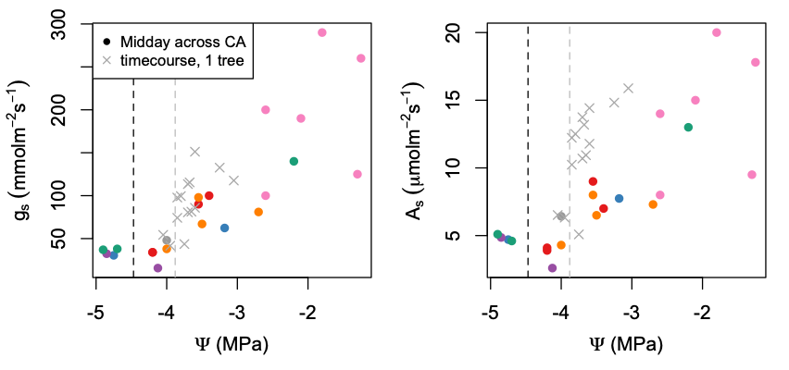

**Figure 4:** *Stomatal conductance (a) and photosynthesis (b) as a function of leaf water potential. Filled circles show midday gas exchange and water potential values (color indicates different sites). Gray x’s indicate the morning time-course of a single tree as it approached midday. The gray and black vertical lines indicate the leaf and stem P50 of blue oak from Skelton et al. 2019.*

|  |  |
| --- | --- |
|  | **Figure 5:** Terminal branch leaf area to stem area ratio (a, Al:As), leaf mass to stem mass (b, Ml:Ms), mean leaf size (c), leaf mass per area (d, LMA) and leaf dry matter content (e, LDMC) as a function of the best climate, sample year meteorology, or soil predictor based on model selection. Gray points show tree average trait values, black points show site means, solid trend lines show significant relationships (p<0.05). |



**Figure 6:** *End of season water status does not predict growth, but minimum temperature does. (a) Predawn leaf water potential does not predict radial growth, calculated as the realized % of maximum Basal Area Increment given a tree’s DBH. (b) Radial growth increases strongly with increasing minimum temperatures. (c) Transpirative water potential drop (ΔΨ) is weakly related to average stem length (but ΨPD and ΨMD are not, not shown). (d) Stem length is also positively related to site minimum temperature of the coldest month.*

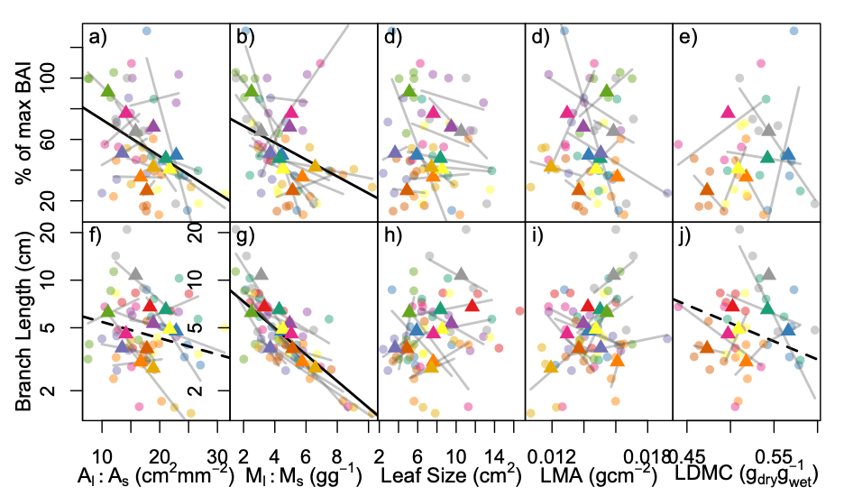

***Figure 7:*** *Relationships between leaf traits, including Al:As (a,f), Ml:Ms (b,g), average leaf size (d, h), LMA (d,i), and LDMC (e,j), and radial growth calculated as the percent of realized Basal Area Increment growth (BAI) relative to the 90th percentile growth for that tree size (a-e), and average branch length of the current year terminal branches (1 year of growth, f-j). Points show tree average traits, triangles show site average traits, gray lines show trends among trees within sites, solid black lines show significant trends from linear mixed effects models, and dashed black lines show marginally significant trends.*

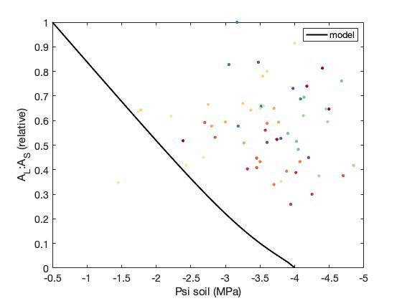

***Figure 8:*** *Comparison of the optimal Al:As of sampled trees simulated by the HOTTER plant hydraulics model forced with observed soil water potential data (line) to the observed Al:As (points). Trees simulated to have an Al:As (soil water potential <-4 MPa) should be drought deciduous in order to maximize carbon gain (minimize carbon loss).*

**Supplemental Information**

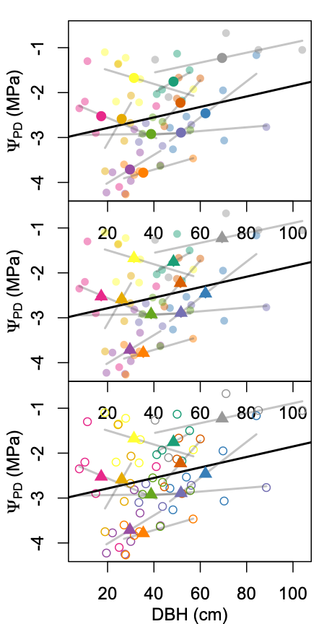

**Figure S1:** *Predawn water potential (ΨPD) was generally less negative in trees with larger diameter at breast height (DBH), suggesting that larger trees had access to increased soil moisture. Points show tree average values, triangles show site average values, colors indicate different sites, and gray lines show the trend among trees at a site. Black trend line show statistically significant (p<0.05) fixed effects from a mixed model with site random intercepts*



**Figure S2:** *Plant water potentials were strongly related to xylem water isotopes within and among sites (similar to Fig. 3 but with δ18O). Predawn leaf water potential (a), midday leaf water potential (b) and the difference between them (c) decrease with increasing xylem water enrichment of δ18O. Points show tree average values, triangles show site average values, colors indicate different sites, and gray lines show the trend among trees at a site. Black trend line show statistically significant (p<0.05) fixed effects from a mixed model with site random intercepts, with the outlier burned site (gray points, triangle) excluded.*

**Table S1:** Summary of among-site variability in water status, traits and growth.

|  |  |  |  |  |  |  |  |  |
| --- | --- | --- | --- | --- | --- | --- | --- | --- |
| Trait | n | eta2 | omega2 | Among site p-value | CV | Best environmental predictor | Env predictor p | Env variance explained |
| PD | 83 | 0.76 | 0.71 | 0 | 0.46 | 30yr AET | 0.108 | 0.132 |
| MD | 86 | 0.6 | 0.52 | 0 | 0.23 | WY PPT 2018 | 0.191 | 0.074 |
| E.drop | 82 | 0.66 | 0.58 | 0 | 0.59 | GS VPD 2018 | 0.011 | 0.245 |
| Al_As | 60 | 0.45 | 0.32 | 0.001 | 0.29 | 1m Soil H2O Storage | 0.02 | 0.187 |
| ml_ms | 60 | 0.33 | 0.17 | 0.037 | 0.44 | Tmin 2018 | 0.012 | 0.176 |
| leafsize | 60 | 0.51 | 0.39 | 0 | 0.43 | 30yr PPT | 0.026 | 0.197 |
| LMA | 60 | 0.48 | 0.35 | 0 | 0.12 | PAW | 0.019 | 0.201 |
| LDMC | 40 | 0.66 | 0.58 | 0 | 0.07 | SP Tmax 2018 | 0.116 | 0.212 |
| Length | 60 | 0.43 | 0.3 | 0.002 | 0.35 | Tmin 2018 | 0.043 | 0.145 |
| perc_maxBAI | 59 | 0.35 | 0.21 | 0.014 | 0.57 | 30yr Tmin | 0.01 | 0.186 |

**Table S2**: Model results predicting leaf water potential from xylem water stable isotopes. p: p-value of isotope predictor in linear mixed effect model with site as random effect. R2m: marginal R2 (considering fixed effects); R2c: conditional R2 (including both fixed and random effects) from linear mixed effects models. ‘btw site R2’: the amount of among-site variation in water potential explained by isotopic predictor based on linear model of site-averaged data.

|  |  |  |  |  |  |  |  |  |
| --- | --- | --- | --- | --- | --- | --- | --- | --- |
|  | δD | | | | δ18O | | | |
| All data | p | R2m | R2c | btw site R2 | p | R2m | R2c | btw site R2 |
| ΨPD | **0.012** | **0.181** | **0.672** | **0.216** | **0.046** | **0.08** | **0.634** | **0.223** |
| ΨMD | **0.015** | **0.154** | **0.669** | **0.012** | **0.028** | **0.093** | **0.581** | **0.033** |
| E.drop | **0.006** | **0.23** | **0.389** | **0.575** | 0.065 | 0.086 | 0.42 | 0.419 |
| no PWD outlier |  |  |  |  |  |  |  |  |
| ΨPD | **0** | **0.605** | **0.636** | **0.829** | **0.004** | **0.21** | **0.536** | **0.573** |
| ΨMD | **0.001** | **0.362** | **0.469** | **0.498** | **0.001** | **0.271** | **0.346** | **0.356** |
| E.drop | **0.003** | **0.297** | **0.455** | **0.612** | 0.06 | 0.094 | 0.478 | 0.409 |

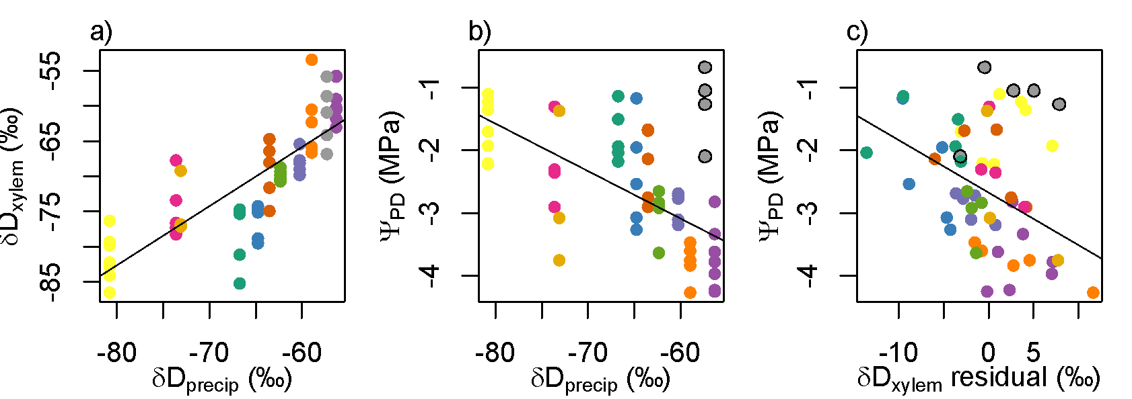

**Figure S3:** The isotopic values of meteoric water (δDprecip) are positively related to the δDof tree xylem water (a), and negatively related to soil water availability (ΨPD, b). However, the residuals of the δDxylem~δDprecip relationship (i.e. how enriched xylem is relative to a site’s precipitation-weighted average meteoric context) still predicted soil moisture availability (c), with more relatively enriched xylem water being associated with more negative ΨPD. Patterns with δ18O are qualitatively similar to those shown with δD.



**Figure S4:** Best climate predictors (excluding soil characteristics) of leaf and allocation traits, based on AICc-based model selection.Gray points show tree averages, black points site averages, and black trend lines significant relationships based on linear mixed effects models (dashed line is marginally significant).

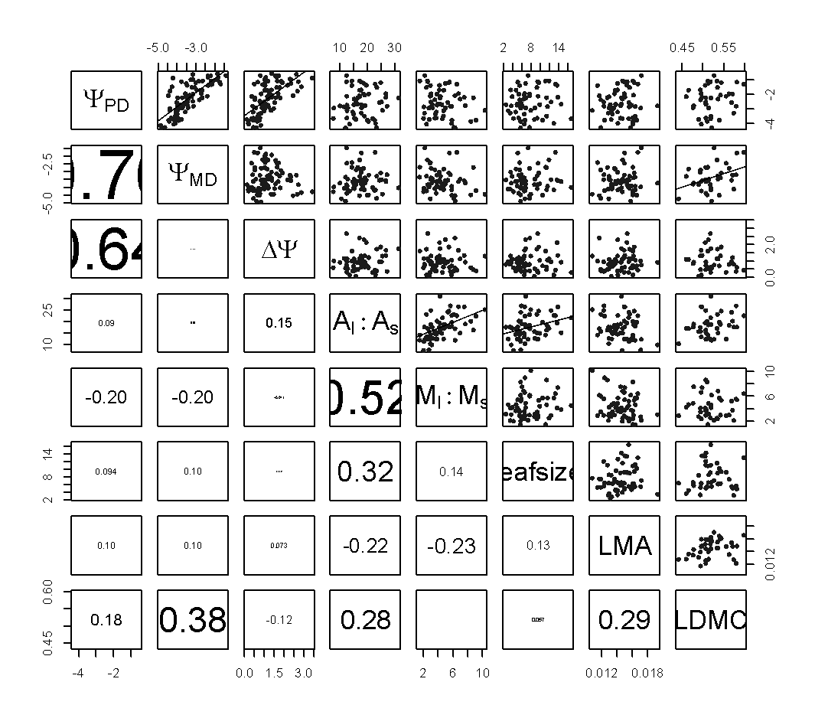

**Figure S5:** Pair plots of water potentials and leaf and allocation traits. Upper diagonal shows scatterplots between variables (significant correlations p<0.5 with trend lines) and lower diagonal shows correlation coefficients (text scaled by correlation absolute value).

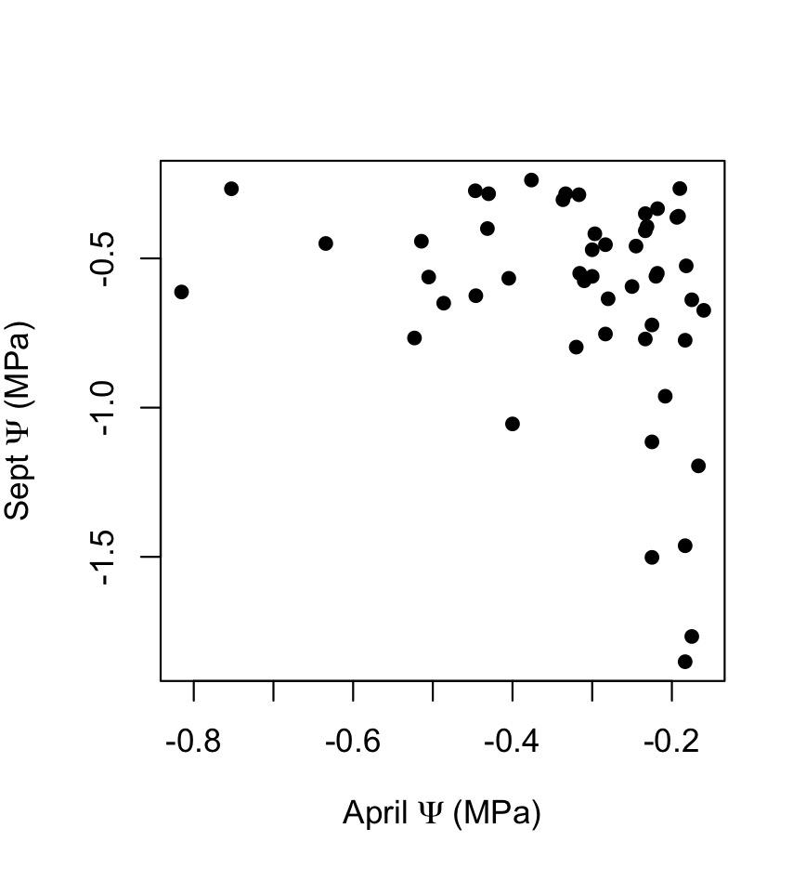

***Figure S6:*** *At the UC Sedgwick Reserve in southern California, predawn leaf water potentials measured in April 2023 were negatively correlated with predawn water potentials measured in September 2023 across 42 blue oak trees distributed across the landscape. (I Boving unpublished data).*

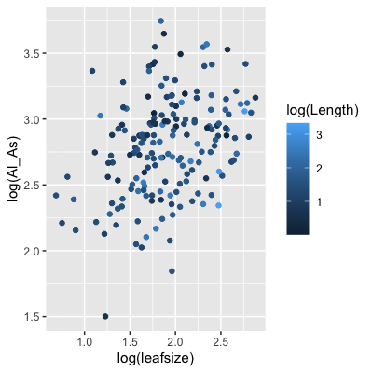

**Figure S7:** Al:As at the branch level is jointly controlled by leaf size (larger leaves produce higher Al:As, linear mixed effects model with site and tree random intercept p<0.0001) and branch length (longer branches produce lower Al:As, p=0.006).

Fixed effects:

Estimate Std. Error df t value Pr(>|t|)

(Intercept) 2.28783 0.15343 91.55937 14.911 < 2e-16 ***

log(Length) -0.12612 0.04503 162.95509 -2.801 0.00572 **

log(leafsize) 0.36052 0.07036 122.67828 5.124 1.13e-06 ***